Press Statement
ZDA signs MoU with Invest Africa to boost Investor Relations
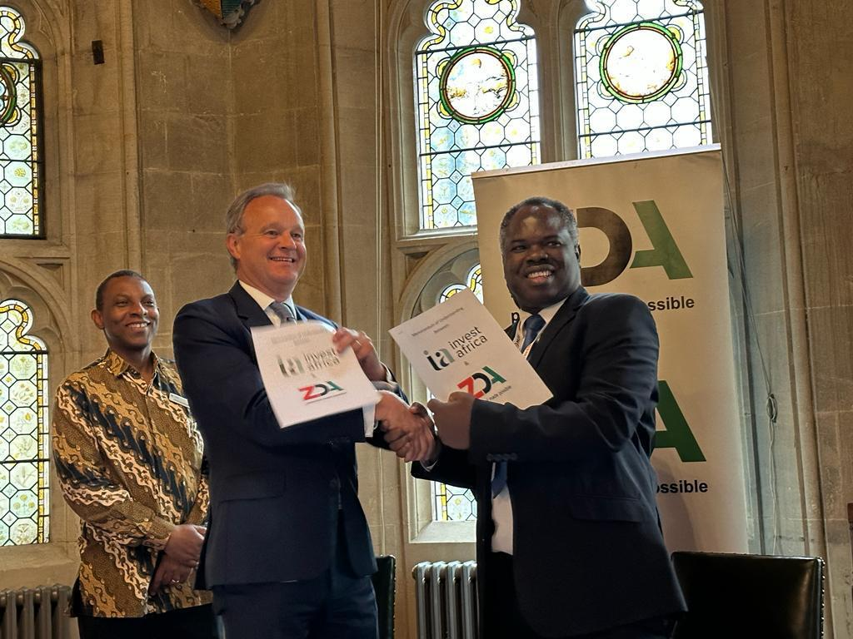
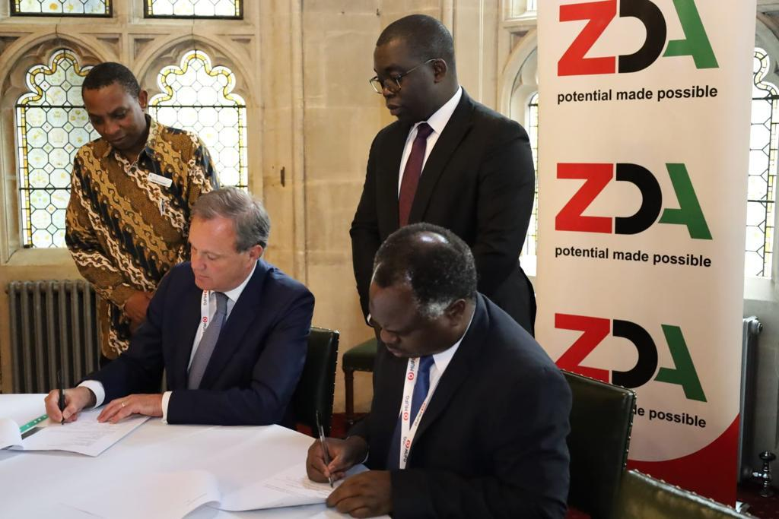

Alongside the many investor engagements in the United Kingdom that were undertaken by the Republican President, His Excellency Mr. Hakainde Hichilema, the Zambia Development Agency (ZDA) and Invest Africa Limited (IA) signed a Memorandum of Understanding to promote Foreign Direct Investment missions into Zambia.

The two parties agreed to work jointly to mobilise investments into Zambia from the United Kingdom, Europe, the United States of America, the Middle East and Africa. In addition, promotional activities will be held in Zambia and the United Kingdom on a reciprocal basis. Investment forums will also be held in the United States of America alongside the United Nations General Assembly and in South Africa during the Mining Indaba.

Mr. Albert Halwampa, ZDA Director General and Rt. Hon. Mark Simmonds, Chairman of the IA, Advisory Board signed the Memorandum of Understanding (MoU) on the sidelines of the Invest Africa Conference, at the Guildhall in London on 11th May 2023.

The Minister for Commerce Trade and Industry Hon. Chipoka Mulenga witnessed the signing between the two organisations. Other notables in attendance were Mines Minister Hon. Paul Kabuswe, Energy Minister Hon. Peter Kapala, Special Assistant to the President: Finance and Investments Mr. Jito Kayumba and ZDA Board Member Mr Mike Couvaras.

Issued By Kwali Mfuni (Ms.)
Manager Communications and Public Relations
Zambia Development Agency

